Advanced Command Prompt Tasks
- System information
# systeminfo
- Wmic
cpu
gives processor details
- Windows system’s serial number
# wmic bios get serialnumber
- set the system time
time HH:MM:SS
time 14:30:00
- What ipconfig does:
When you run ipconfig in Command Prompt, it displays information about your network adapters, such as:
IP Address (IPv4 & IPv6)
Subnet Mask
Default Gateway
DNS Servers (if configured)
MAC address (when used with ipconfig /all)
- Delete Windows Temporary Files
# del /q /f /s %TEMP%\*
Clear Windows Update Cache
net stop wuauserv
net stop bits
del /q /f /s C:\Windows\SoftwareDistribution\Download\*
net start wuauserv
net start bits
- Check Battery performance
# powercfg /batteryreport
C:\Users\Akash\battery-report.html.
- Shortcut keys from cmd
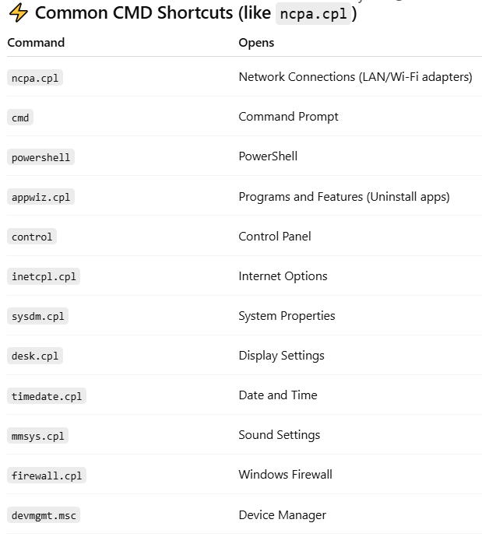
- Create folder
mkdir C:\akash
rmdir C:\akash
- Ping status
113.11.231.80
113.11.231.59
113.11.231.57

Network Diagnostics & Monitoring
- netstat -ano
Shows all active connections with process IDs (helpful for finding malware/unauthorized connections).
tracert <domain>
Trace the route packets take to a destination (useful for network troubleshooting).
pathping <domain> → Combines ping + tracert, gives detailed packet loss reports.
arp -a View ARP table (shows all devices connected in LAN).
- User & Security Management
# net user
List all users on the system.
# net user <username> <password> /add
Create a new local user.
# net localgroup administrators <username> /add
Add user to the admin group.
- System Information & Performance
# systeminfo
Complete system details (OS, patches, BIOS, RAM, etc.).
# wmic product get name,version
List all installed software with versions.
# Tasklist /v
Show detailed list of running processes.
# taskkill /PID <id> /F → Forcefully kill a process by PID.

- Networking Tricks
ipconfig /displaydns → Show cached DNS records.
ipconfig /flushdns → Clear DNS cache.

- Powerful Tricks
# sfc /scannow
Scan & repair corrupted system files.
# chkdsk /f /r
Check & repair hard disk errors.
- telnet
telnet 113.11.23.50 50
- Check Hash value of file
certutil -hashfile "C:\Users\Akash\Downloads\saras.docx" SHA256
- How to find Sharing files
# net share
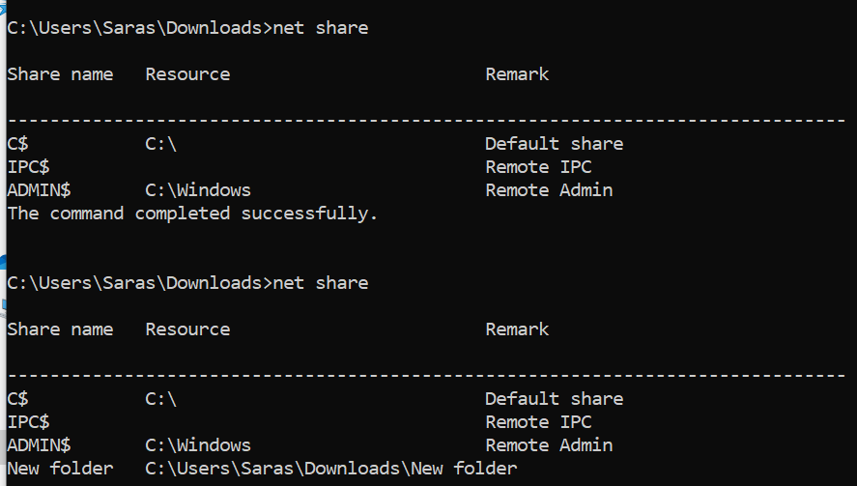
- Route Table details
# route print
- Check Domain records
nslookup -type=MX example.com
nslookup -type=NS example.com
nslookup -type=CNAME www.example.com
nslookup -type=TXT example.com

